**DAY 14 LIT ASSIGNMENT**

**Name : Abdul Sameerunnisa**

**ID : 46247725**

CDS-Assignment 1 – Create a Simple CDS view with Date Functions in ABAP CDS Views

**Scenario** –

* Create a CDS view with 7 fields from VBAK using date functions

1. VBELN (Sales Document),
2. AUART (Sales Document Type),
3. AUDAT (Document Date),
4. VDATU (Requested delivery date)
5. Days between Document Date & Requested delivery date as Processing days
6. Delivery date + 10 days as shipping date
7. Delivery Date + 2 months as billing date

**Tables involved** – VBAK

**CDS VIEW : ZAS_LIT_DAY14_Q1**

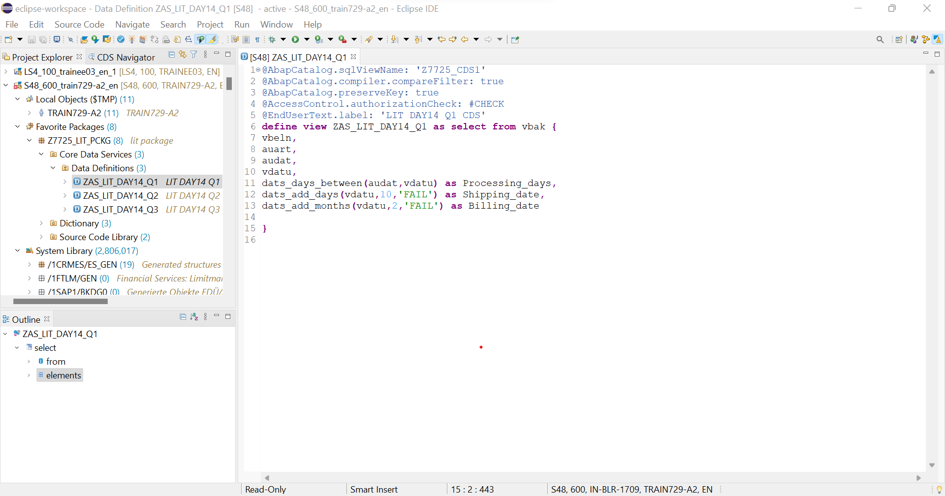

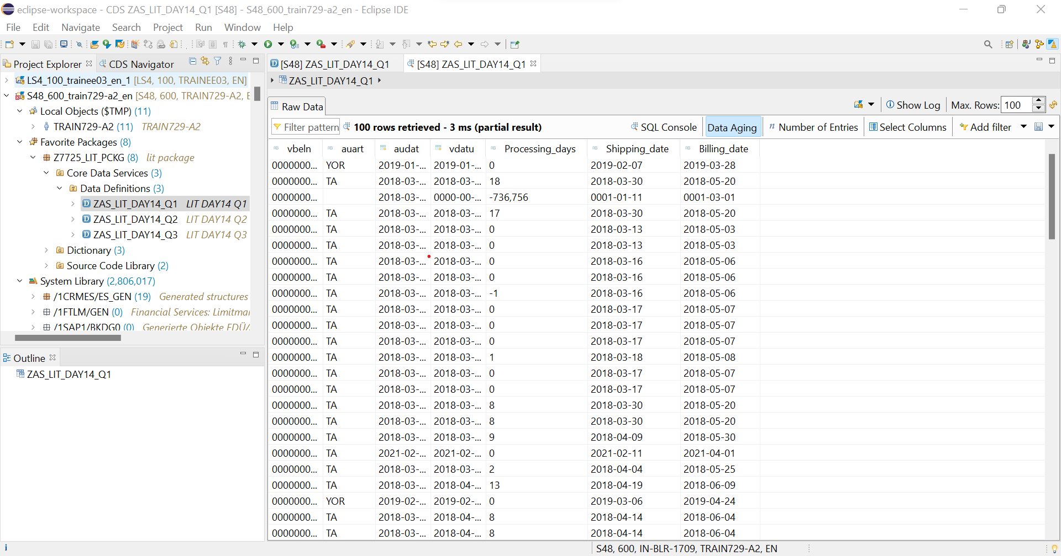

CDS-Assignment 2 – Create a Simple CDS view with String Functions in ABAP CDS Views

**Scenario** –

* Create a CDS view with 10 fields from KNA1 using string functions

1. KUNNR (Customer Number),
2. LAND1 (Country Key),
3. Concatenate NAME1 & NAME2
4. Concatenate STRAS, ORT01 & REGIO & PSTLZ with space in between.
5. Get first 2 characters of NAME1
6. Get last 3 characters of NAME2
7. No of characters of TELF1
8. NAME1+2(4). 4 characters starting from 2nd character.
9. Remove the leading zeros of KUNNR
10. Remove last 4 characters of TELF1.

**Tables involved** – KNA1

**CDS VIEW : ZAS_LIT_DAY14_Q2**

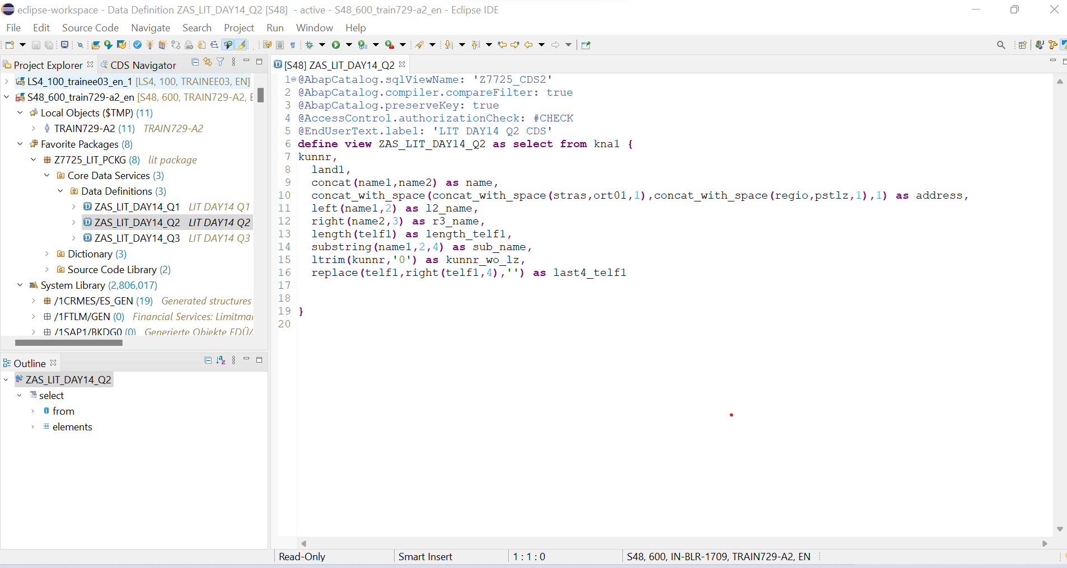

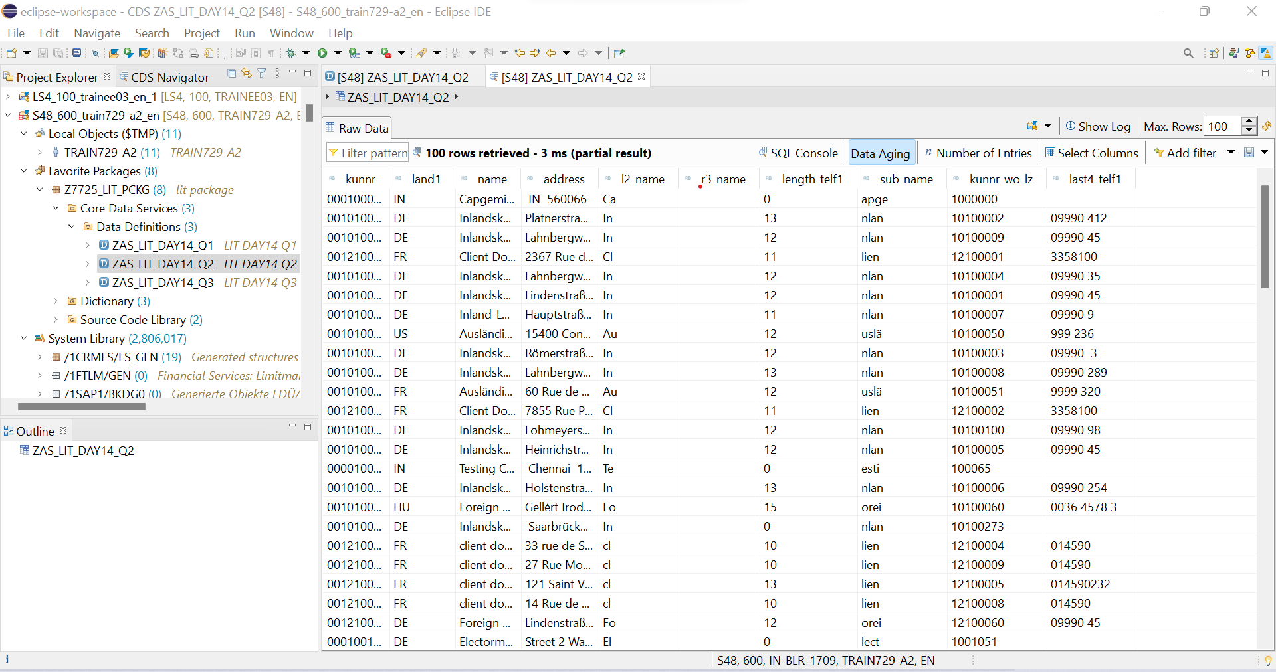

CDS-Assignment 3 – Create a Simple CDS view with Parameters

**Scenario** –

* Create a CDS view with GL currency (PSWSL) as parameter and get the entries form BSEG

**Tables involved** – BSEG

**CDS VIEW : ZAS_LIT_DAY14_Q3**

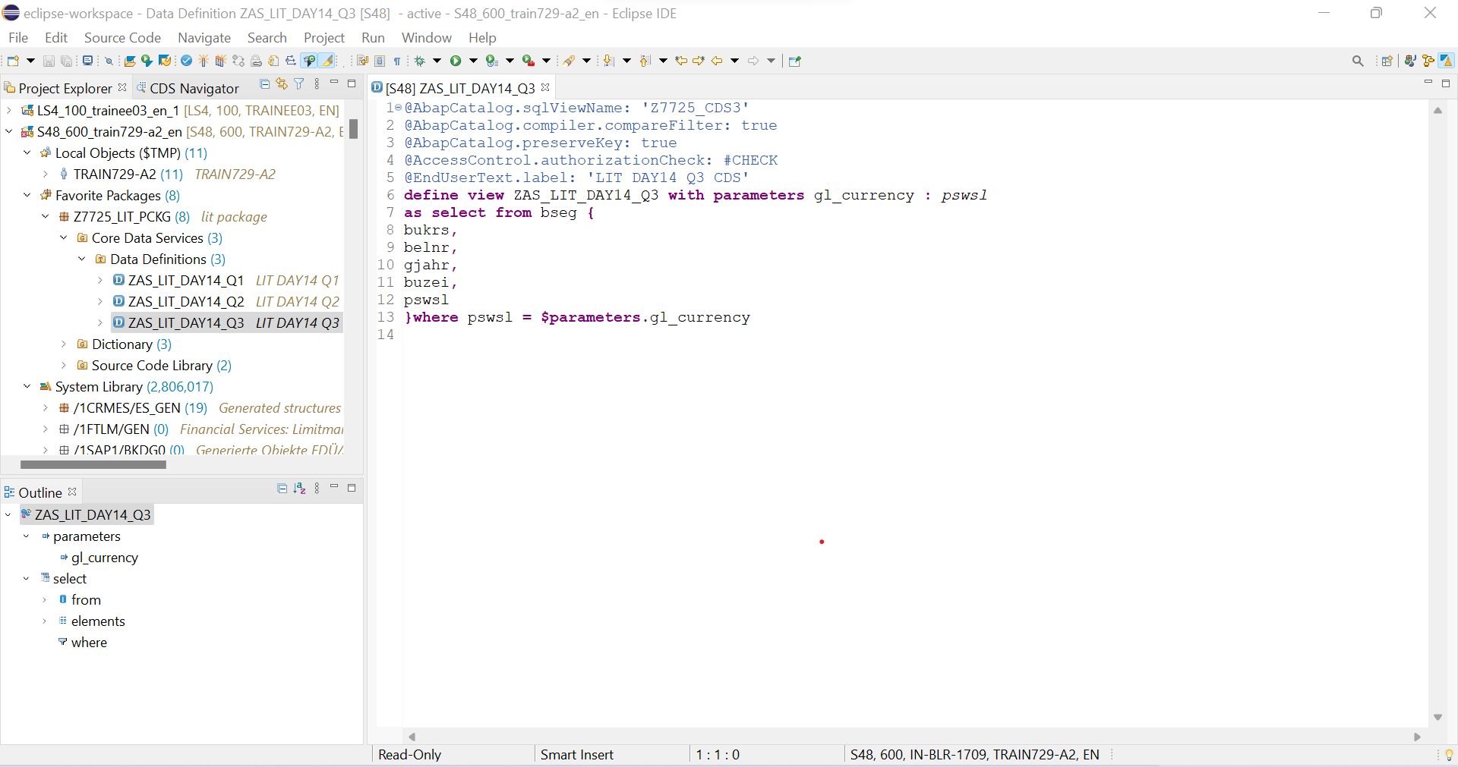

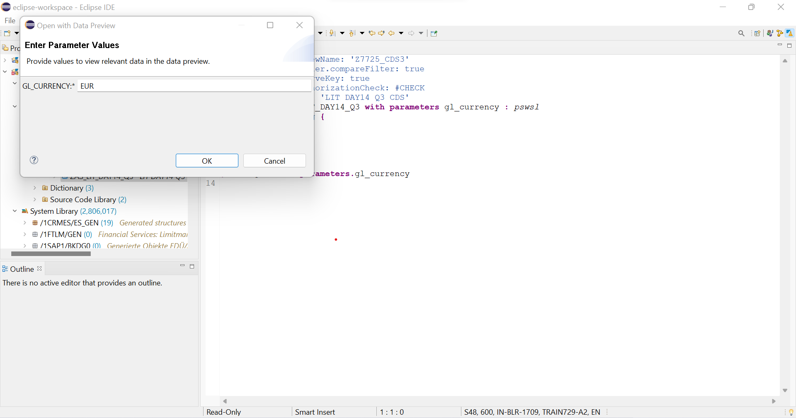

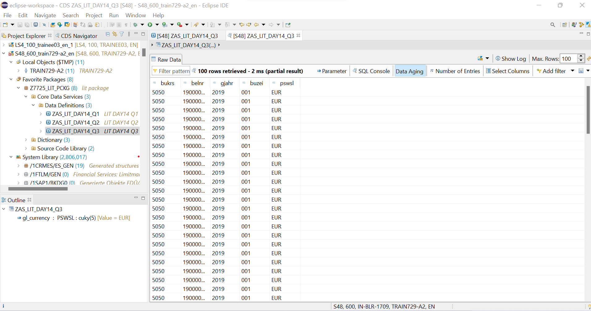

AMDP-Assignment 1 – Procedures - create a basic procedure to fetch data with scalar variable

**Scenario** –

* Print Sales Order number, Material Number, Quantity from VBAP table using scaler variable

**Tables involved** – VBAP

**CLASS NAME : ZAS_LIT_DAY14_Q4**

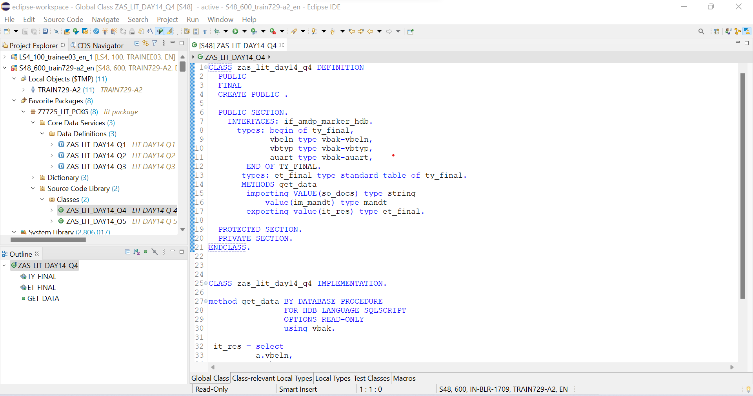

**Report : ZAS_LIT_DAY14_Q4**

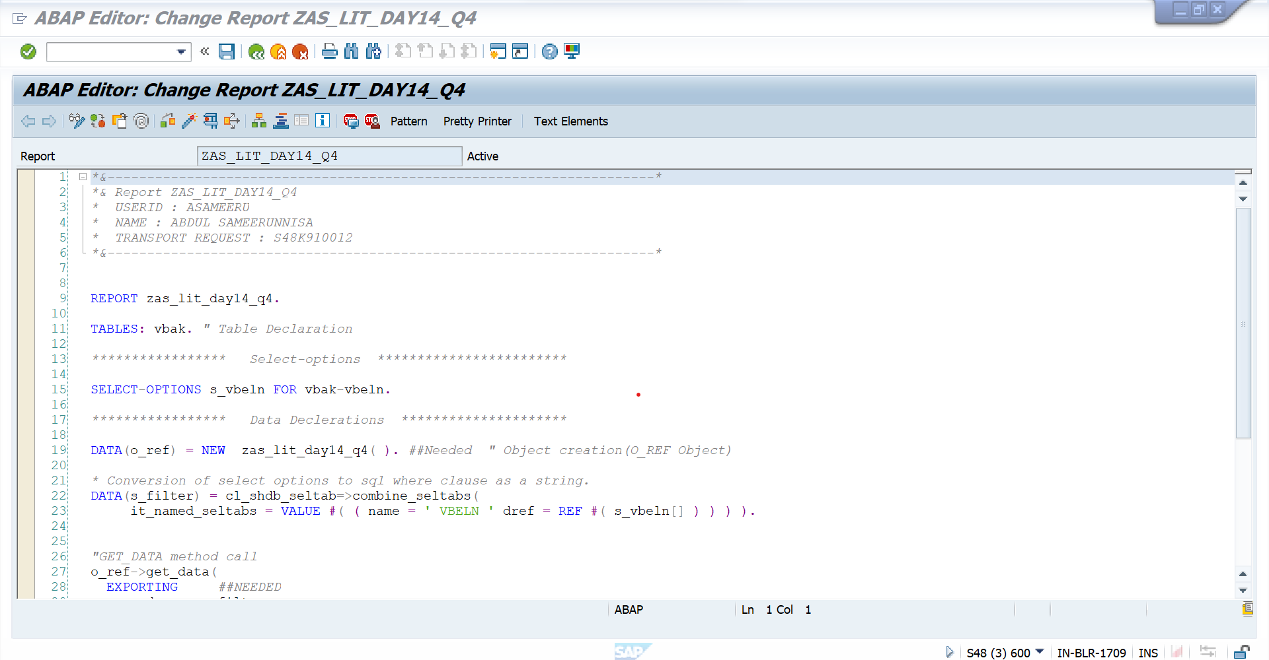

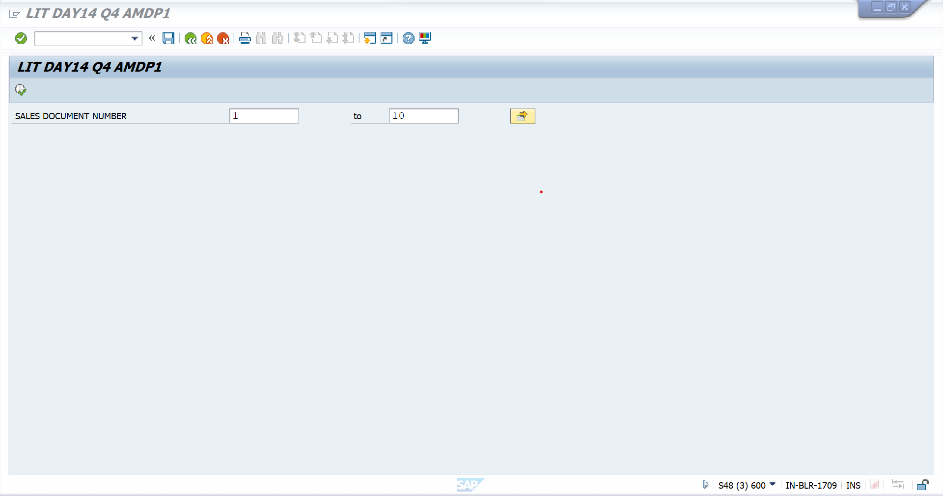

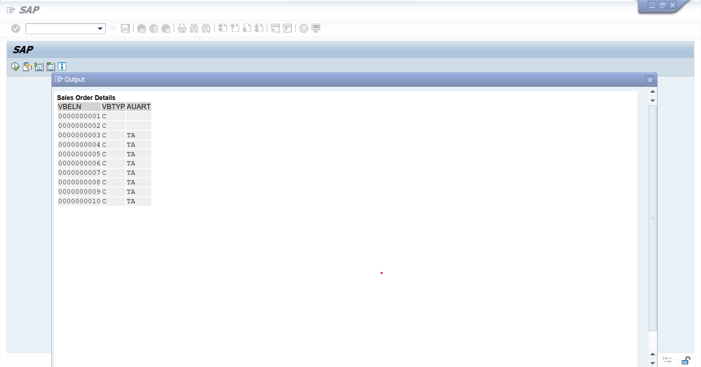

AMDP-Assignment 2 – Procedures - create a basic procedure with Table

**Scenario** –

* Select VBELN, VKORG, MATNR, MENGE from VBAK and VBAP and display the data using table based on material (MATNR).
* MATNR will be input field
* Do inner join

**Tables involved** – VBAK, VBAP

**CLASS NAME : ZAS_LIT_DAY14_Q5**

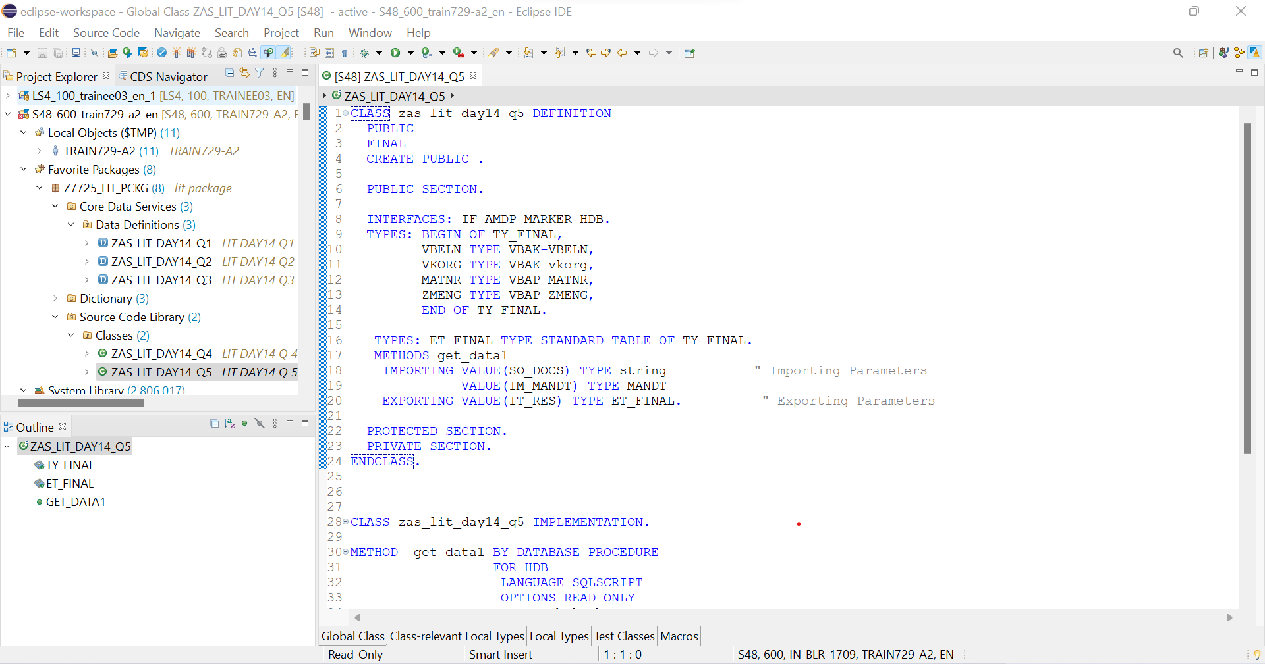

**Report : ZAS_LIT_DAY14_Q5**

